Fakulta riadenia a informatiky

**SEMESTRÁLNA PRÁCA**

Pokročilé databázové systémy

Zadanie E

Martin Graňák, 5ZZS12

Dominik Maťašovský, 5ZZS14

Zadanie 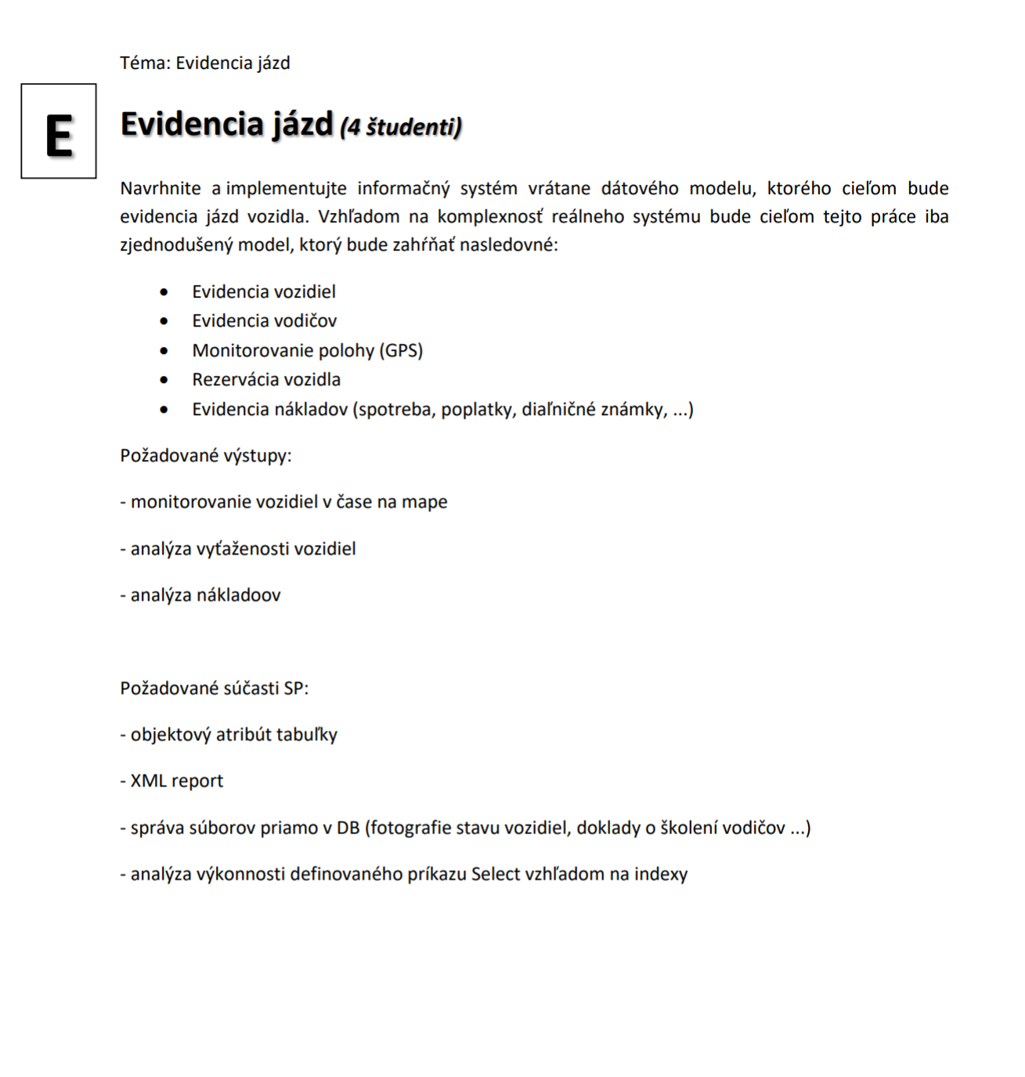Použite technológie

* Maven
* Springboot
* myBatis
* PostgreSQL,
* Java
* Angular
* flywayDB
* Rest
* XML

Schéma

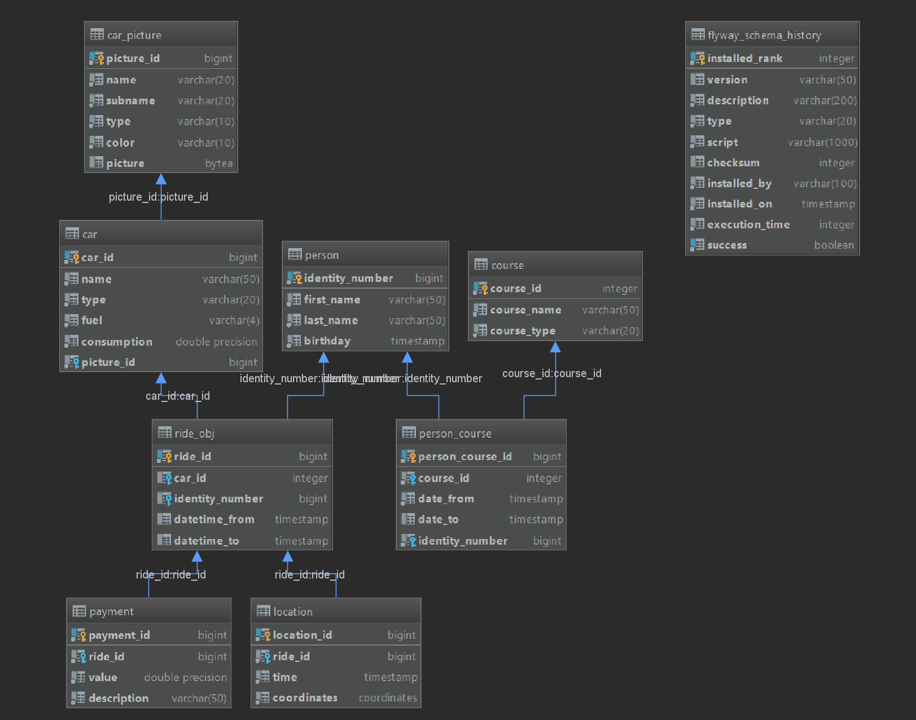

Generátor schémy

**create** sequence hibernate_sequence;  
**alter** sequence hibernate_sequence owner **to** postgres;  
  
**create type** coordinates **as**(  
 longitute **real**,  
 latitude **real**);  
**alter type** coordinates owner **to** postgres;  
  
**create type** ride **as**(  
 ride_id bigint,  
 car_id **integer**,  
 identity_number bigint,  
 datetime_from **timestamp**,  
 datetime_to **timestamp**);  
**alter type** ride owner **to** postgres;  
  
**create table** if **not exists** car  
(  
 car_id bigserial **not null  
 constraint** car_pkey  
 **primary key**,  
 **name varchar**(50) **not null**,  
 **type varchar**(20) **not null**,  
 fuel **varchar**(4) **not null**,  
 consumption **double precision not null**,  
 picture_id bigint **not null**);  
**alter table** car owner **to** postgres;  
  
**create table** car_picture  
(  
 picture_id bigserial **not null  
 constraint** car_picture_pk  
 **primary key**,  
 **name varchar**(20) **not null**,  
 subname **varchar**(20) **not null**,  
 **type varchar**(10) **not null**,  
 color **varchar**(10) **not null**,  
 picture bytea  
);  
**alter table** car_picture owner **to** postgres;  
  
**alter table** car **ADD CONSTRAINT** car_picture_car_picture_id_fk **FOREIGN KEY** (picture_id) **REFERENCES** car_picture (picture_id) **on update cascade on delete cascade**;  
  
**create table** if **not exists** course  
(  
 course_id serial **not null  
 constraint** course_pk  
 **primary key**,  
 course_name **varchar**(50) **not null**,  
 course_type **varchar**(20) **not null**);  
**alter table** course owner **to** postgres;  
  
**create table** if **not exists** person  
(  
 identity_number bigint **not null  
 constraint** person_pk  
 **primary key**,  
 first_name **varchar**(50) **not null**,  
 last_name **varchar**(50) **not null**,  
 birthday **timestamp not null**);  
**alter table** person owner **to** postgres;  
  
 **create table** if **not exists** person_course  
(  
 person_course_id bigserial **not null  
 constraint** driver_course_pk **primary key**,  
 course_id **integer not null  
 constraint** driver_course_course_course_id_fk  
 **references** course **on update cascade on delete cascade**,  
 date_from **timestamp not null**,  
 date_to **timestamp**,  
 identity_number bigint **not null  
 constraint** person_course_person_identity_number_fk  
 **references** person **on update cascade on delete cascade**);  
**alter table** person_course owner **to** postgres;  
  
**create table** if **not exists** ride_obj **of** ride  
(**CONSTRAINT** ride_obj_pk **PRIMARY KEY** (ride_id));  
  
**alter table** ride_obj **ADD CONSTRAINT** ride_obj_car_car_id_fk **FOREIGN KEY** (car_id) **REFERENCES** car (car_id) **on update cascade on delete cascade**;  
**alter table** ride_obj **ADD CONSTRAINT** ride_obj_person_identity_number_fk **FOREIGN KEY** (identity_number) **REFERENCES** person (identity_number) **on update cascade on delete cascade**;  
**alter table** ride_obj owner **to** postgres;  
  
**create table** if **not exists** location  
(  
 location_id bigserial **not null  
 constraint** location_pk  
 **primary key**,  
 ride_id bigint **not null  
 constraint** location_ride_obj_ride_id_fk  
 **references** ride_obj  
 **on update cascade on delete cascade**,  
 **time timestamp default CURRENT_TIMESTAMP not null**,  
 coordinates coordinates **not null**);  
**alter table** location owner **to** postgres;  
  
**create table** if **not exists** payment  
(  
 payment_id bigserial **not null  
 constraint** payment_pk **primary key**,  
 ride_id bigint **not null  
 constraint** payment_ride_ride_id_fk  
 **references** ride_obj **on update cascade on delete cascade**,  
 **value double precision not null**,  
 description **varchar**(50) **not null**);  
**alter table** payment owner **to** postgres;  
  
**create or** replace function picture_import(p_path text, OUT p_result bytea) returns bytea  
 **language** plpgsql  
**as** $$  
**declare** l_oid oid;  
**begin  
 select** lo_import(p_path) **into** l_oid;  
 **select** lo_get(l_oid) **INTO** p_result;  
 perform lo_unlink(l_oid);  
**end**;  
$$;  
**alter** function picture_import(text, out bytea) owner **to** postgres;  
  
**create or** replace function seed_car_pictures(p_path text, p_result out boolean)  
**language** plpgsql **as** $$  
**declare** pictures **cursor for select** * **from** car_picture;  
**begin** p_result := **false**;  
 **for** pic **in** pictures  
 loop  
 **UPDATE** car_picture **SET** picture = *picture_import*(p_path || pic.name || '\' || pic.type || '\' || pic.subname || '-' || pic.color || '.jpg') **WHERE** picture_id = pic.picture_id;  
 **end** loop;  
 p_result := **true**;  
**end**;$$;  
**alter** function seed_car_pictures(text, out bytea) owner **to** postgres;

Požadovane výstupy

* výpis platieb za daný mesiac v XML

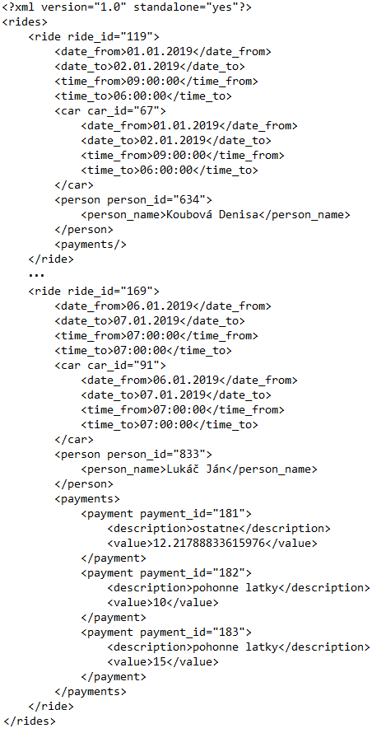

* výpis platieb podľa jazdy a typu
* výpis vodičov (osoba ktorá ma aktuálne platný vodičsky preukaz a skolenie o vedení vozidla patriaceho referentskej firme)

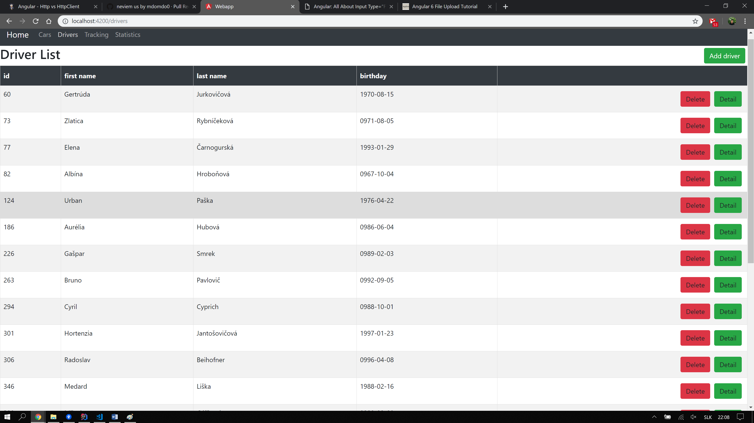

* výpis všetkých rezervácii a údajov s nimi spojenými
* zobrazenie polôh daného vozidla na mape

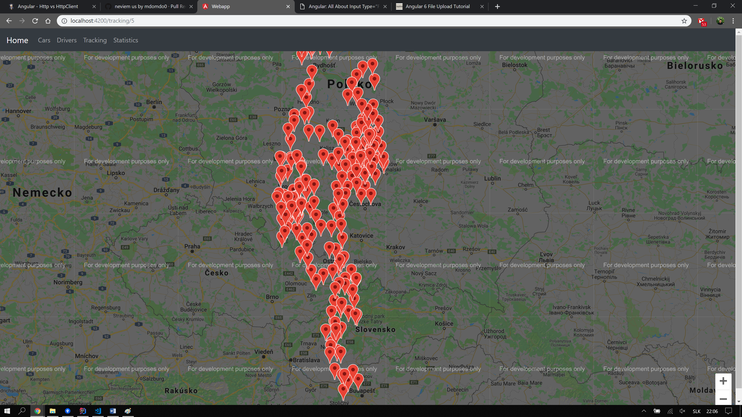

* výpis všetkých aut po stránkach s obrázkami

